

**A**

**PROJECT REPORT**

**ON**

**CURRENCY CONVERTER**

**FYMCA SEMESTER I**

**COURSE: MCA7PM02A-DISCRETE MATHEMATICS**

**Submitted By**

|  |  |
| --- | --- |
| **1132230646**  **1132230659** | **Mehul Bhatia**  **Prajayshee Chauhan** |
| **1132230664**  **1132230315** | **Aswathy Panicker**  **Sakshi Jaiswal** |
|  |  |

**IN PARTIAL FULFILLMENT OF**

**MASTER OF COMPUTER APPLICATION (SCIENCE)**

**Submitted Through**

**Department of Computer Science and Applications**

**To**

**DR. VISHWANATH KARAD MIT WORLD PEACE UNIVERSITY, PUNE, MAHARASHTRA, INDIA -411038**



**DEPARTMENT OF COMPUTER SCIENCE AND APPLICATIONS**

Certificate

This is to certify that**, Mehul Bhatia, Prajayshee Chauhan, Aswathy Panicker, Sakshi Jaiswal** studentsof MCA (Science) Semester I has/have successfully / partially completed project on MCA7PM02A-Discrete Mathematics in partial fulfilment of MCA (Science) Sem I under Dr. Vishwanath Karad MIT World Peace University, for the academic year 2023-2024.

______________

Dr. Anuradha Kanade

**Internal Guide**

Dr. Jalindar Gandal Dr. Rajeshree Khande

**Program Head Program Director**

Date: ___/___/______

External Examiners:

1. ____________________________ 2. ____________________________

**ACKNOWLEDGEMENT**

Working with this incredible group has been an enriching and rewarding experience. We would like to express our sincere appreciation to each member for their outstanding contributions, collaboration, and commitment to our common goals. **Mehul Bhatia, Prajayshee Chauhan, Aswathy Panicker, Sakshi** Jaiswal your collective efforts and expertise were instrumental in the success of our endeavors. The synergy of our diverse skills and perspectives created a dynamic and innovative working environment. We also want to acknowledge the support and guidance provided by Prof. Anuradha Kanade. Your leadership and mentorship have been invaluable in steering the group towards excellence. To every member who played a role, big or small, in the achievements of our group, we extend my gratitude. Together, we have not only accomplished our objectives but also fostered a positive and collaborative team spirit. We feel privileged to have been part of such an exceptional group, and we look forward to future collaborations and shared successes.

|  |  |
| --- | --- |
| 1132230646  1132230659 | **Mehul Bhatia**  **Prajayshee Chauhan** |
| 1132230664  1132230315 | **Aswathy Panicker**  **Sakshi Jaiswal** |

**DECLARATION**

We, the undersigned members of our group, hereby declare that the work offered in this project is the result of our combined efforts. Each team member has made significant contributions to the project's research, analysis, and development. All information sources used have been properly recognised, and the project is a true picture of our collective work. We confirm that the project has not been submitted for academic review elsewhere and is free of plagiarism.

|  |  |  |
| --- | --- | --- |
| 1132230646  1132230659 | **Mehul Bhatia**  **Prajayshee Chauhan** | Signature  Signature |
| 1132230664  1132230315 | **Aswathy Panicker**  **Sakshi Jaiswal** | Signature  Signature |
|  |  |  |
|  |  |  |

**TABLE OF CONTENTS**

|  |  |  |
| --- | --- | --- |
| **SR. NO** | **TOPIC** | **PAGE NO.** |
| **1** | Introduction | 4 |
| **2** | Project Scope | 5 |
| **3** | Objectives | 6 |
| **4** | Environment Description | 7 |
| **5** | Analysis | 8 |
| **6** | Design Report (Input and Output) | 9 |
| **7** | Limitations |  |
| **8** | Future Enhancement |  |
| **9** | Conclusion |  |
| **10** | References |  |

**INTRODUCTION**

Currency converters are essential tools for individuals and businesses involved in international transactions or travel. They simplify the complexities of different currencies by providing real-time exchange rates and allowing users to accurately convert monetary values. Currency converters are crucial for ensuring financial clarity and precision, facilitating seamless transactions and fostering economic interactions across borders. They reflect current exchange rates between two or more currencies, influenced by factors like economic indicators, geopolitical events, and market dynamics. With digital advancements, currency converters are easily accessible online and through mobile applications, providing up-to-date information, historical trends, and user-friendly interfaces. This allows users to plan and execute financial transactions with confidence. Currency converters play a vital role in simplifying global financial interactions and empowering individuals and businesses in navigating the intricacies of diverse currencies.

**PROJECT SCOPE**

The currency converter project scope includes designing a user-friendly and efficient digital tool that allows users to correctly convert monetary values between different currencies. The major goal is to develop a responsive online application or mobile app that delivers real-time exchange rates drawn from trustworthy financial data streams. The currency converter will handle different currencies and allow users to enter quantities for conversion, with the corresponding value shown in the preferred currency. Historical exchange rate tracking, user customisation for preferred currencies, and a simple, straightforward UI will be key elements. The project scope includes assuring the correctness of exchange rate computations, putting in place a secure data processing system, and optimising the tool for a smooth user experience. Furthermore, the scope may be expanded to include other capabilities.

**OBJECTIVE**

The currency converter project aims at providing users with a dependable, easy-to-use, and smooth currency conversion tool. The main objective of the project is to help individuals and businesses involved in international transactions by providing real-time exchange rate information and accurate conversion of currency values between different currencies. The goal of the currency converter is to simplify the complexities of global currencies, so that users can make financial decisions and carry out transactions with confidence. The goal of this project is to provide a digital platform, be it a web application or a mobile application, that not only provides current exchange rate information, but also includes features such as historical rate tracking, customization, and a user-friendly interface. The goal is to improve financial clarity and efficiency across borders, catering to the various needs of users in a connected and globalized world.

**ENVIRONMENT DESCRIPTION**

In the context of the currency converter, the environment includes the digital environment, where the seamless financial transactions take place across different global markets. In this environment, the project operates within online platforms, such as a web app or a mobile application, taking advantage of the connectivity and availability of the internet. In the digital environment, currency converters interact with real time financial data feeds in order to guarantee the accuracy of the exchange rates. Currency converters are designed to be easy to use, with an easy-to-understand interface that can accommodate users from different backgrounds. Security is a top priority for currency converters, so it is essential that they have strong data protection measures in place to protect user information as well as transaction details.The currency converter exists in the context of the globalized economy. It serves as a reliable means of navigating and understanding the intricacies of diverse currencies for individuals, travelers and investors, as well as businesses involved in international trade.

**ANALYSIS**

An analysis of the currency converter reveals its critical role in streamlining and enhancing financial interactions in the globalized digital age. The tool's strengths lie in its ability to provide real-time exchange rates, enabling users to accurately convert monetary values between different currencies. This facilitates international transactions, travel, and investment by offering users a quick and reliable method to assess the equivalent value of their currency in a foreign context. Additionally, the currency converter's historical rate tracking feature allows users to analyze trends, aiding in decision-making for future financial activities. Its accessibility through web applications and mobile platforms ensures widespread availability and ease of use, making it an indispensable resource for individuals and businesses navigating the complexities of diverse currencies. However, challenges may arise in maintaining up-to-date rates and ensuring the security of user data, necessitating robust data protection measures. In essence, the currency converter serves as a vital tool in the modern financial landscape, fostering efficiency and informed decision-making in the dynamic realm of global transactions.

**DESIGN REPORT (INPUT AND OUTPUT)**

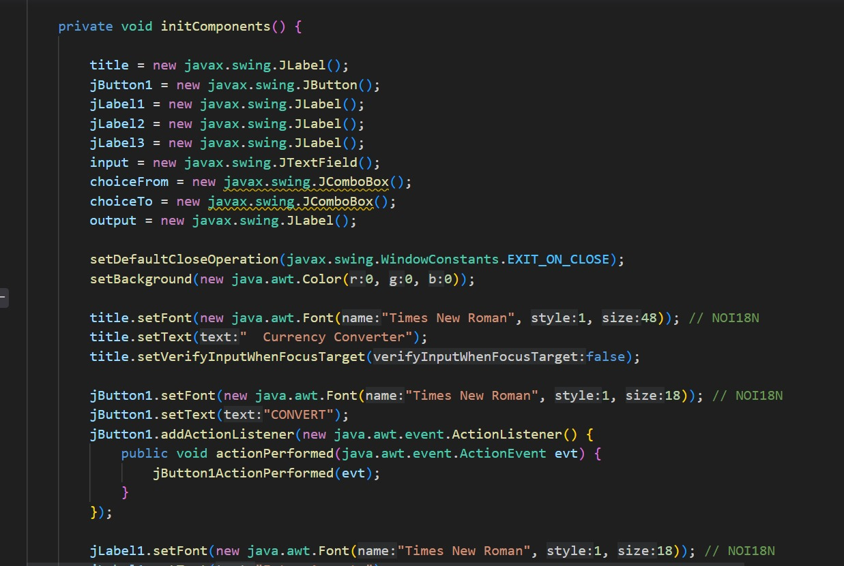

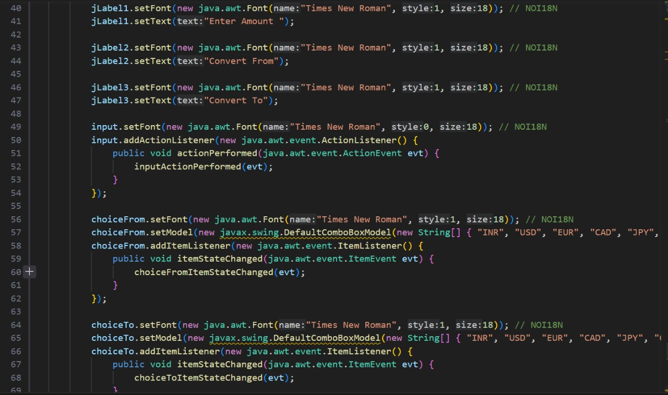

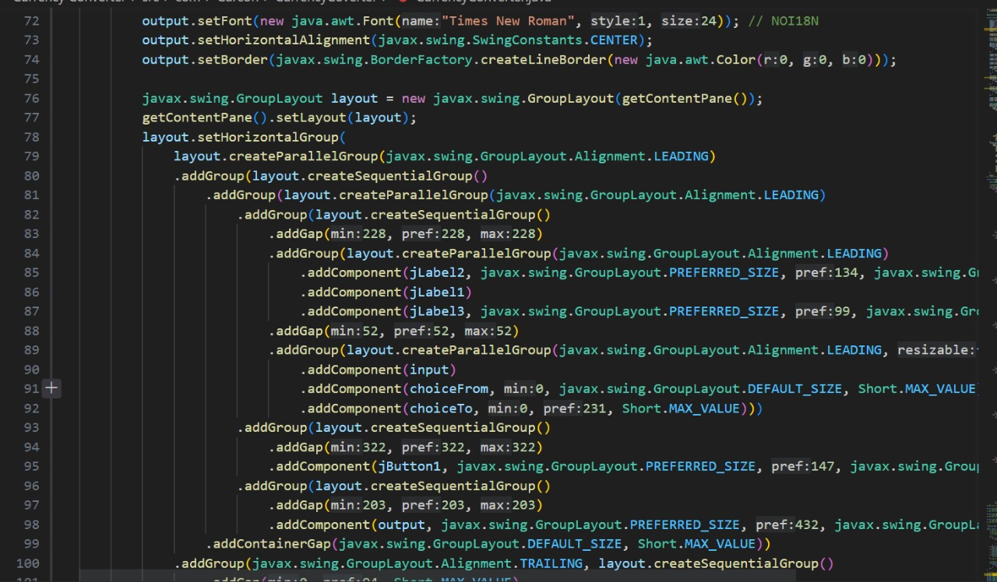

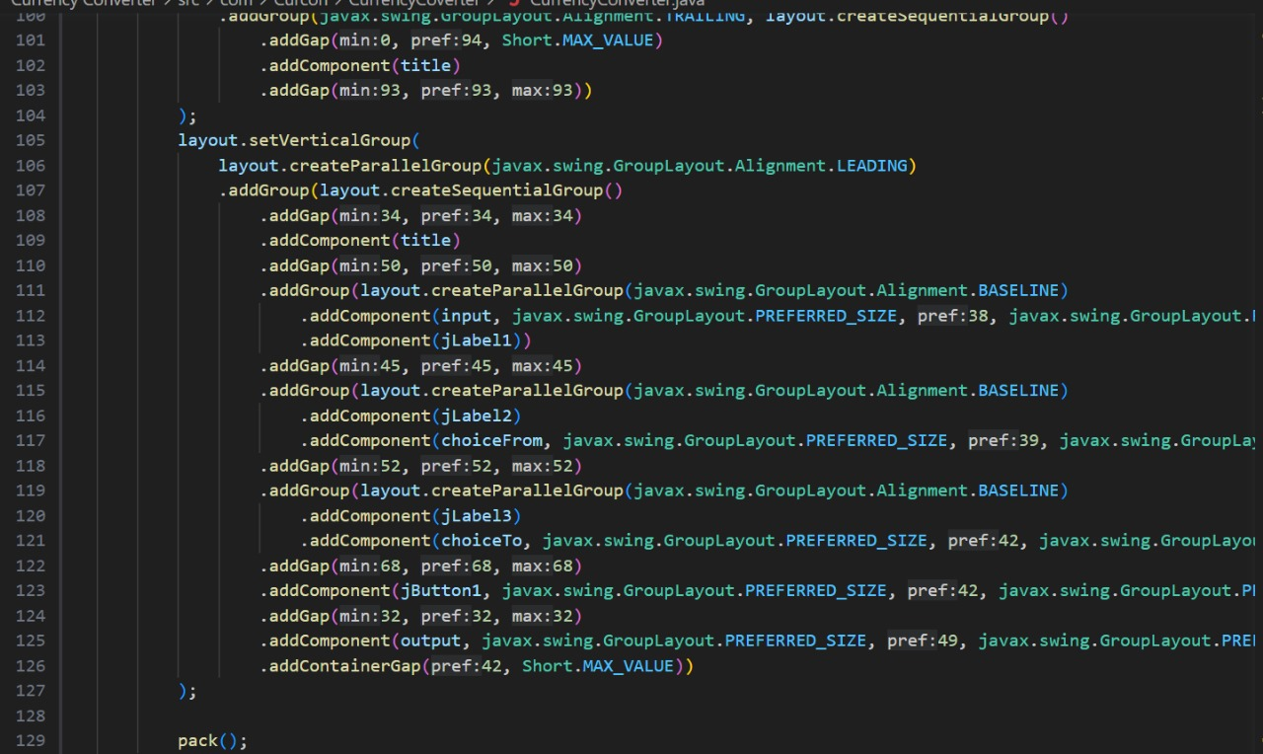

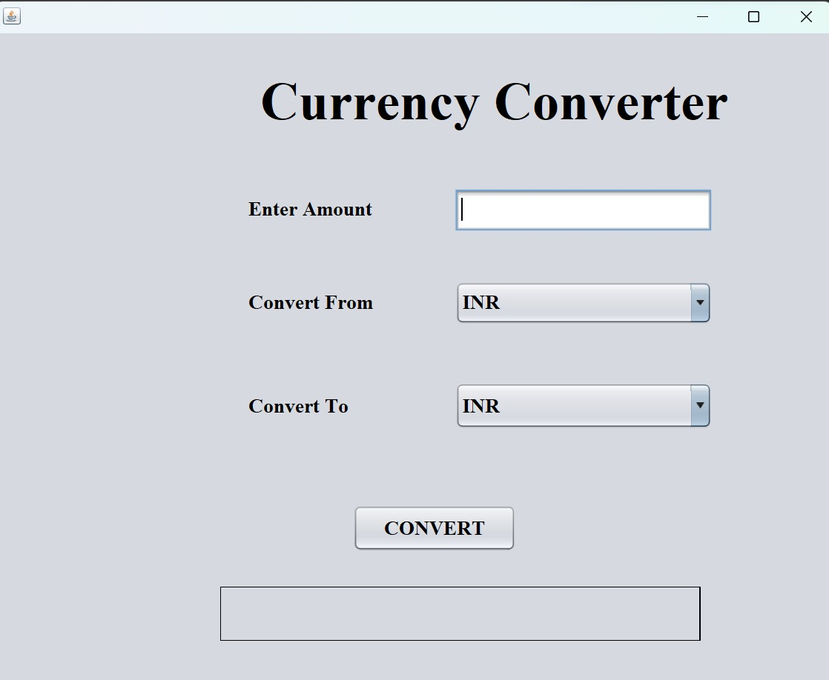

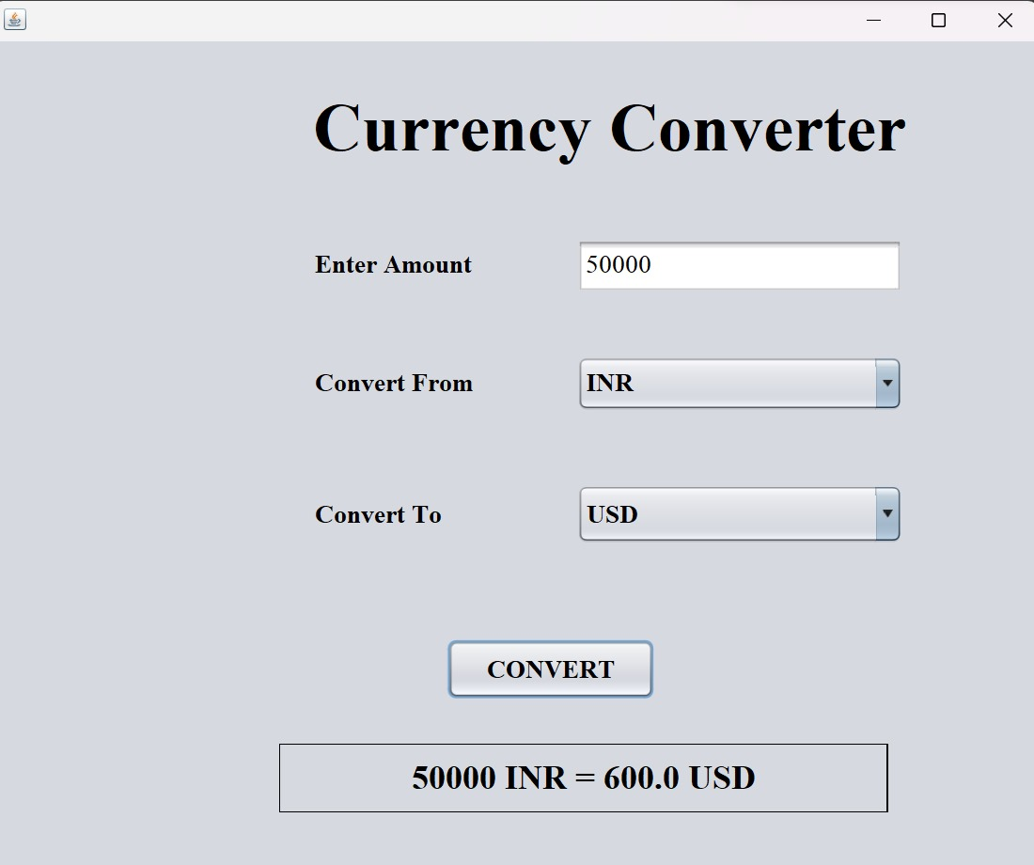

**LIMITATIONS**

Despite its valuable functionalities, currency converters have inherent limitations that users should be aware of. One significant constraint is the reliance on real-time exchange rates, which are subject to constant fluctuations due to market dynamics. As a result, the displayed equivalent values may vary between the time of conversion and the actual transaction, potentially leading to discrepancies. Additionally, the accuracy of exchange rates depends on the data sources used, and discrepancies may arise if these sources are not updated promptly. Another limitation is the lack of consideration for transaction fees and charges imposed by financial institutions, which can affect the actual amount received or exchanged. Furthermore, the currency converter may not account for regional variations in pricing or purchasing power, leading to disparities in real-world expenses. Users must exercise caution and supplement converter results with a comprehensive understanding of additional factors influencing currency exchanges, ensuring a more informed approach to international financial transactions.

**FUTURE ENHANCEMENTS**

Future enhancements for the currency converter could revolve around incorporating advanced features and technologies to further improve user experience and accuracy. Integration with artificial intelligence (AI) and machine learning algorithms could enable the currency converter to analyze historical data more effectively, providing users with predictive trends and insights into potential currency fluctuations. Enhanced customization options, such as personalized user profiles and preferences, could offer a tailored experience for individuals with specific currency needs. Additionally, integrating blockchain technology for secure and transparent transactions might address concerns related to data security and transaction authenticity. Collaboration with financial institutions and fintech companies could lead to real-time updates on transaction fees and charges, ensuring users receive more accurate conversion results. Furthermore, exploring augmented reality (AR) or virtual reality (VR) interfaces could introduce innovative ways for users to visualize and interact with currency conversions, making the process even more intuitive. Overall, the future of currency converters lies in a convergence of advanced technologies to provide users with a more sophisticated, reliable, and user-centric financial tool.

**CONCLUSION**

In conclusion, the currency converter stands as an indispensable tool in the dynamic landscape of global financial interactions. As an integral component of the digital era, it plays a pivotal role in empowering individuals, businesses, and travelers to navigate the complexities of diverse currencies with ease and precision. While acknowledging its strengths in providing real-time exchange rates and historical data, it is crucial to recognize its limitations, such as the ever-changing nature of currency values and potential discrepancies in real-world transactions. Looking ahead, the future of currency converters holds exciting possibilities with the integration of advanced technologies like AI, blockchain, and enhanced customization options. Despite its current capabilities, continual advancements and collaborations promise to make the currency converter even more sophisticated, secure, and user-friendly, ensuring its relevance and effectiveness in facilitating seamless international financial transactions in the years to come.

**REFERENCES**

1. Google Search: You can use Google Search by typing queries like "USD to EUR" to get the latest exchange rates.
2. Siri or Google Assistant: Virtual assistants on mobile devices often have built-in currency conversion capabilities.
3. Bloomberg, CNBC, Reuters: Financial news websites often include currency converters as part of their market data sections.
4. Many major banks provide currency conversion tools on their websites. Check with your bank for this feature.